Chocolate Sales
Data Analysis Report
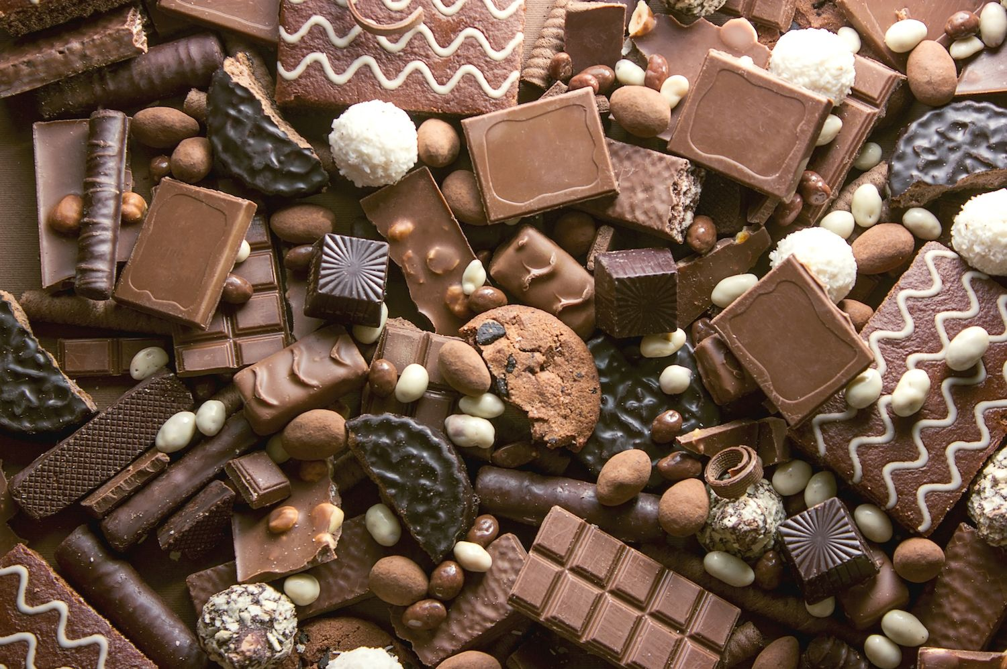

Excel for Data Analysis
Anuj Pawar
Introduction
This report provides a comprehensive analysis of the chocolate sales data collected throughout the year 2022. The objective of this analysis is to identify key trends, evaluate sales performance across different countries and products, and highlight the contributions of individual sales personnel. By examining total sales amount, boxes shipped, and average price per box, this document aims to offer actionable insights to optimize sales strategies and improve overall business performance. The findings herein will serve as a foundational overview of the company's performance, providing a clear picture of market strengths and areas for potential growth.

INFORMATION ABOUT DATASET
- Sales Person->This column contains the name of sales persons who made the sale
- Country->This column contains the country where the sale took place.
- Product->This column contains the specific chocolate product that was sold.
- Date->This column contains the date of the transaction.
- Amount->This column contains the total sales revenue generated from the transaction.
- Boxes Shipped->This column contains the number of boxes of the product sold in that transaction.

DATA PREPRATION
We have four column “Sales Person”, “Country”, “Product” and “Date” which are independent to each other and the column “Amount” and “Boxes Shipped” are dependent column.

DATA CLEANING
Converted all columns with four matching data types as given below
- “Sales Person”, ”Country” and “Product” columns are converted to Text format
- Column “date” is converted to Date format
- Column “amount” is converted to Currency format
- Column “boxes shipped” is converted to Number format

QUICK INSIGHTS
- The 50% Dark Bites and Eclairs are the products which meets the highest count, each making up 5.48% of the total transactions.
- The top performing country is Australia with 18.74% of the total product selling.
- The top performing sale person is Kelci Walkden with 4.94% of total performance and top performer for box shifted is Karlen McCaffrey with 5.46%.

DETAILED INSIGHTS
Row Labels | Count of Product
Andria Kimpton | 3.56%
Barr Faughny | 3.93%
Beverie Moffet | 4.57%
Brien Boise | 4.84%
Camilla Castle | 2.93%
vChes Bonnell | 4.39%
Curtice Advani | 4.20%
Dennison Crosswaite | 4.48%
Dotty Strutley | 3.29%
Gigi Bohling | 4.30%
Gunar Cockshoot | 3.93%
Husein Augar | 3.47%
Jan Morforth | 3.56%
Jehu Rudeforth | 3.93%
Kaine Padly | 4.11%
Karlen McCaffrey | 4.30%
Kelci Walkden | 4.94%
Madelene Upcott | 4.11%
Mallorie Waber | 3.75%
Marney O'Breen | 4.11%
Oby Sorrel | 4.48%
Rafaelita Blaksland | 3.11%
Roddy Speechley | 3.93%
Van Tuxwell | 4.66%
Wilone O'Kielt | 3.11%
Grand Total | 100.00%

From above graph we can say that the best performer for selling product is Kelci Walkden.

Row Labels | Count of Product
50% Dark Bites | 5.48%
70% Dark Bites | 3.84%
85% Dark Bars | 4.57%
99% Dark & Pure | 4.48%
After Nines | 4.57%
Almond Choco | 4.39%
Baker's Choco Chips | 3.75%
Caramel Stuffed Bars | 3.93%
Choco Coated Almonds | 3.56%
Drinking Coco | 5.12%
Eclairs | 5.48%
Fruit & Nut Bars | 4.57%
Manuka Honey Choco | 4.11%
Milk Bars | 4.48%
Mint Chip Choco | 4.11%
Orange Choco | 4.30%
Organic Choco Syrup | 4.75%
Peanut Butter Cubes | 4.48%
Raspberry Choco | 4.39%
Smooth Sliky Salty | 5.39%
Spicy Special Slims | 4.94%
White Choc | 5.30%
Grand Total | 100.00%

From the graph we can say that the best sold chocolate product was 50% Dark Bites and Eclairs.

Row Labels | Sum of Boxes Shipped
Andria Kimpton | 3.64%
Barr Faughny | 3.60%
Beverie Moffet | 5.21%
Brien Boise | 4.58%
Camilla Castle | 3.04%
Ches Bonnell | 4.25%
Curtice Advani | 4.00%
Dennison Crosswaite | 4.95%
Dotty Strutley | 3.87%
Gigi Bohling | 3.56%
Gunar Cockshoot | 3.77%
Husein Augar | 3.30%
Jan Morforth | 4.33%
Jehu Rudeforth | 4.09%
Kaine Padly | 4.10%
Karlen McCaffrey | 5.46%
Kelci Walkden | 4.92%
Madelene Upcott | 4.11%
Mallorie Waber | 3.38%
Marney O'Breen | 4.54%
Oby Sorrel | 4.86%
Rafaelita Blaksland | 2.43%
Roddy Speechley | 3.90%
Van Tuxwell | 3.84%
Wilone O'Kielt | 2.28%
Grand Total | 100.00%

From the graph we can say that the best performer for box shifting per transaction is Karlen McCaffrey

ACTION STEPS
As New Zealand has lowest percentage in sold products, to expand there business they have to reduce price or give offer on some product.

